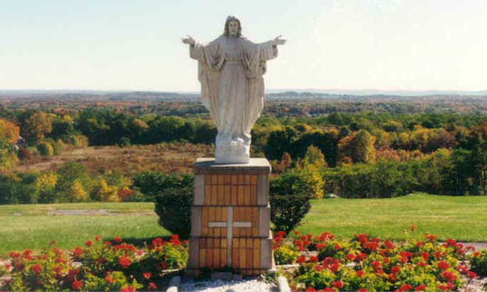
Secular Franciscan Order
Our Lady of the Angels Regional Fraternity
Annual Retreat
July 31 – August 2, 2015

Mt. Alvernia Retreat House
Wappingers Falls, NY
Retreat Master: Fr. Thomas Hartle, OFM

Arrival: Friday between 5 and 7 PM (refreshments, but no supper). Departure: after lunch, Sunday.
Cost $175.00 payable with registration. Includes presentations, double room, private bath and five full meals. Please note there are a limited number of individual rooms.

Directions:
From Westchester:
Take either the Taconic Parkway or Route 684 to Route 84 West. Take 84 West to Exit 13 (Route 9 North/Poughkeepsie) Take route 9 North for about 8 miles, you will Home Depot on right, continue a few traffic lights, pass route 9 Mall (Kohl’s department Store & Borders Book Shop), now move into LEFT lane at next traffic light turn left onto Route 9D (also called West Main St.) follow 9D passing the first light (South Hills Mall) at next light make right turn onto Delavergne Ave. go up hill Mt Alvernia is on your left.

From New Jersey:
Take either Route 17; Garden State Parkway or Palisades Parkway North to I 87 New York State Thruway. Follow I 87 North to I 84 East (Exit 17) follow I 84 to exit 13 Route. Take route 9 North for about 8 miles, you will Home Depot on right, continue a few traffic lights, pass route 9 Mall (Kohl’s department Store & Borders Book Shop), now move into LEFT lane at next traffic light turn left onto Route 9D (also called West Main St.) follow 9D passing the first light (South Hills Mall) at next light make right turn onto Delavergne Ave. go up hill Mt Alvernia is on your left.

From New York City:
Go over George Washington Bridge and follow directions above from New Jersey.

Just a reminder, retreatants may arrive after 5PM, however, there is no meal Friday night. Route 9 has many restaurants for those who wish to stop.

There are a limited number of partial scholarships available. For additional information contact: Richard Spana, OFS
(914) 478-2010
rickspanasfo@aol.com
________________________________________________________________________________________________________
Registration Form Please check one ____Professed ____Candidate 2015 Retreat

Name:___________________________________________________________________________________________________
Address:_________________________________________________________________________________________________
City:__________________________________________________________State:_______________Zip____________________
Phone:__________________________________________ E mail___________________________________________________
Fraternity:_________________________________________________Single room:________ Double room________________
Special Needs:__________________________________ Room with:________________________________________________
Send completed registration with $175.00 check, payable to “Our Lady of the Angels Regional Fraternity “to: Richard Spana, ofs 332 Warburton Avenue, Hastings on Hudson, NY 10706

