Secular Franciscan Order

Our Lady of the Angels Regional Fraternity

October 23, 2012

Dear Fraternity Minister,

With this letter I am convoking the annual Regional Chapter of Ministers meeting to be held on November 10th, 2012. It is the serious responsibility of every fraternity minister to be present or to send a delegate to the Chapter meeting in his or her place. The Chapter of Ministers is the meeting of the full Regional Council of our Regional Fraternity—the highest governmental body of our Regional Fraternity.

Article 63 of the General Constitutions of the SFO defines the Regional Chapter in the following way: “The regional chapter is the representative organ of all the fraternities existing within the confines of a regional fraternity, with elective and deliberative power.”
This is the Regional Council which is constituted by all of the local fraternity ministers within our Regional Fraternity together with the members of the Regional Executive Council.

As the elected local minister of your fraternity, one of your most serious responsibilities to the Order is to represent your local fraternity at this annual meeting and in this way participate in the governance of the Regional Fraternity.

Our principal speaker for the on-going formation portion of our meeting will be Sister Lillian Alam, FMM. Sister was formerly a staff member with Franciscans International and is currently on the Pastoral staff at Holy Name of Jesus Church, 96th Street in New York. She will address the issues surrounding human trafficking.

This year, the Chapter of Ministers meeting will take place at St. Francis of Assisi Church in the San Damiano Hall, 129 West 31st Street, New York, NY 10001. The local fraternity should reimburse the local minister or delegate for any expense involved for transportation to and from this meeting.

There will be time for dialogue with your fellow fraternity ministers and Regional leadership, setting the future direction of our Region, and of course, we will also engage in the important business items before the Chapter including the Regional Budget.

In order to prepare yourself for the discussion, I ask that you please review the enclosed documents :
- the proposed agenda/schedule of the day
- Also included are directions to reach St. Francis of Assisi Church in New York City.

If you have any items which you would like to propose for the agenda, please send them to me to be in my hands no later than November 5th. My e-mail address is pihokkro@rcan.org or you can send any items you may have by regular postal service to me at 377 Rutherford Blvd. Clifton, NJ 07014-1220.

Please be sure to complete the enclosed form indicating either your attendance or naming a delegate to represent your fraternity. A delegate should be a member of your local fraternity council but if this is not possible, then they must, at least, be a permanently professed member. Every fraternity must be represented at this important meeting.

Any member of the Secular Franciscan Order is welcome to attend this meeting as an observer.
You must indicate the name of any observer who plans to attend on the form. There is no cost
for attendance to this meeting. You are requested to bring your own lunch.

I look forward to seeing you on November 10th at St. Francis of Assisi Church, San Damiano Hall in New York, NY. Please pray for the success of our Chapter.

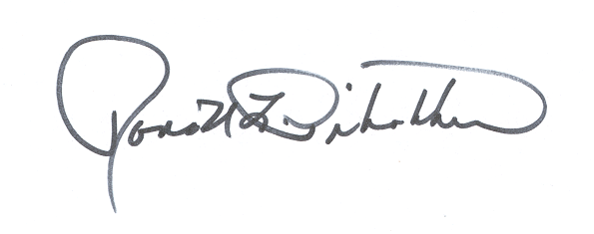
Fraternally,

Ronald L. Pihokker, SFO
Regional Minister
Secular Franciscan Order
Our Lady of the Angels Regional Fraternity

Chapter of Ministers Meeting 2012

St. Francis of Assisi Church
San Damiano Hall
129 W. 31st. Street
New York, NY 10001

Saturday, November 10, 2012

Minister’s Name:________________________________________________

Fraternity:_____________________________________________

Location:______________________________________________

Please check one:

I will attend the Chapter Meeting ________

I am sending a delegate to represent me___________
+++++++++++++++++++++++++++++++++++++++++++++++++++++++
If sending a delegate, please complete below:

The delegate’s name is:__________________________________________

I hereby certify that this delegate is a permanently professed member of my fraternity.

Signature of Minister:________________________________________________

Others attending as observers (please list names):
_______________________________________________________________________________________________________________________________________________

Please complete and return this form by November 5th to:

Kate Asselin, SFO
Regional Secretary
45 Park Avenue, Apt.103
Verona, NJ 07044-2432

DIRECTIONS
St. Francis of Assisi Church---San Damiano Hall
129 West 31st Street, New York, NY 10001

To St. Francis by Subway:
Subway to Herald Square Station
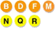
Subway to 7th Ave 34th Street
Subway to 34th Street / Penn Station

To St. Francis of Assisi by train from New Jersey:
PATH from Hoboken or Journal Square to 33rd Street
NJ Transit to Penn Station

Long Island:
LIRR to Penn Station
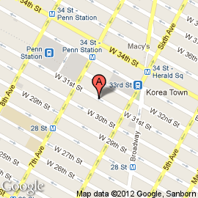
St. Francis of Assisi is located at 135 W. 31st Street, New York, NY 10001
Between 6th and 7th Avenues

